Project Proposal
Airline Reservation & Flight Management System

Course Name: | Data Structures & Algorithms
Submitted To: | Mr. Athar Ikhlaq
Section: | F
Project Title : | Airline Reservation & Flight Management System

Group Members Details
Name | Roll Number
Hafiz Dawood Shafiq | 241980075
Syed Umair | 241980084
Abubakar Sohail | 241980004
Tehami Naveed | 241980101
Muhammad Farooq Adnan Khan (Cap.) | 241980034

Mile-Stone # 2
Features and Functionalities
Project Report: Airline Management System (Milestone 2)

The objective of the Airline Management System is to digitize manual flight and passenger operations. Milestone 2 focuses on establishing a robust backend architecture using Java (OOP) and MySQL, implementing fundamental Data Structures (Arrays), and applying core Algorithms (Sorting/Searching).

- Creation of UML diagram
- Creation of ER diagram

System Architecture :
We have implemented a Layered Architecture to separate concerns, ensuring clean and maintainable code:
- Model Layer (Flight.java, Passenger.java): classes that act as data containers with getters, setters, and constructors.

- DAO Layer (FlightDAO.java, PassengerDAO.java): (Data Access Object) Handles all raw SQL operations (INSERT, SELECT) to isolate database logic from the core application.

- Service Layer (FlightService.java, PassengerService.java): Contains the business logic, algorithms (search/sort), and manages the in-memory arrays.

- Controller Layer (AirlineSystem.java): The main entry point that handles user input (UI) and orchestrates the service layer.

Key Features Implemented

A. Flight Management
- Add Flight (Admin): Allows administrators to add new flight records (Source, Destination, Date, Time, Price, Capacity) to the database.

- View Schedule: Fetches and displays all available flights in a formatted table.

- Seat Management: Implemented an internal seatMap array to track seat availability.

B. Passenger Management
- User Registration: Allows new users toto get added into system . Data is stored persistently in MySQL.

C. Database Persistence
- The system uses JDBC (Java Database Connectivity) to ensure data persists in the MySQL database even after the application is closed.

Data Structures & Algorithms Used

A. Data Structures
- Arrays (1D): Used Flight[] and Passenger[] for in-memory storage to reduce database query overhead during runtime.

- Seat Map: Used arrays with the Flight object to manage seat allocation status.

B. Algorithms
- Linear Search (O(N)): Implemented to allow users to search for specific flights by Flight ID and to verify user existence during login.
- Bubble Sort (O(N^2)): Implemented to sort the flight schedule by Ticket Price (Low to High), assisting users in finding budget-friendly options.

Database Schema:

- Two tables of flight and passengers are integrated in the database till now , just flights can be added into system and passenger can be registered in the system too. Right now , we hasn’t created the booking table to create the system simple for now and will implement it with advanced Data Structures.

Future Roadmap (Milestone 3)
- Linked Lists: To manage dynamic passenger lists for each flight.
- Queues: To implement a waitlist system for fully booked flights.
- Stacks: To implement an "Undo" feature for Admin actions.
- BST: To Search Flight in no time. O(log n).
- Working Track Record:
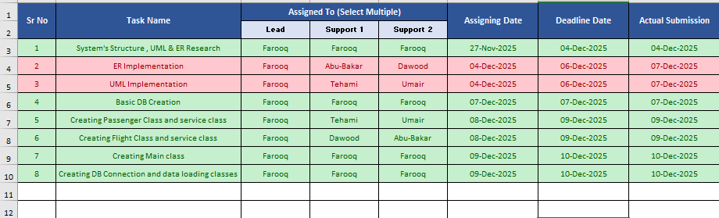

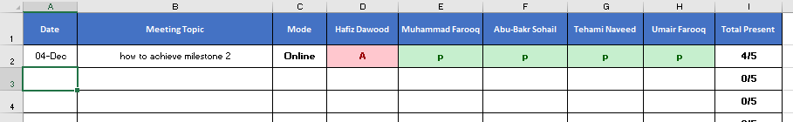
- Attendance Record:

